process typically involves end-users, software engineers, systems administrators, and managers of an organization. The table below describes key concepts associated with information systems analysis and design.

**Table 1: Systems Analysis and Design**

|  |  |
| --- | --- |
| **CONCEPT** | **DESCRIPTION** |
| System Development Life Cycle | The methodology used by systems analysts is called the System Development Life Cycle, or SDLC. Since software applications are typically central to an organization's system, SDLC can also stand for Software Development Life Cycle. Traditionally, the SDLC is divided into a series of phases, from preliminary analysis and design to implementation and maintenance. |
| Waterfall Model | Historically, the waterfall model has been the most widely used development model. It divides the SDLC into a series of sequential or linear phases, from preliminary analysis and design to implementation and maintenance. |
| Iterative Design | Today, most information systems are developed using an iterative process that involves designing, implementing, and testing smaller pieces of the overall project, then cycling back and doing more analysis and design. For example, rather than redesigning the entire system at once, an organization might start by implementing a single enterprise application, such as new sales and marketing software. This process continues until the entire system is in place. The Agile method is one of the most popular iterative models, especially in the software development industry. |
| Planning Phase | The planning phase involves gathering information about the technology and software needs of an organization, deciding which options are most feasible, and setting timelines and deliverables for the entire project. In this phase, the organization decides who will supervise the project and who will be part of the design and development team. The final planning document details the goals of the information system in responding to new business opportunities and making operations more efficient. |
| Analysis Phase | In the analysis phase, the project team takes a close look at any existing information systems that are already in place. For example, if the organization currently uses a transaction processing system to track customer orders, the team will determine if this system is adequate or needs to be upgraded. Does the organization need a better support system to help business leaders make more informed decisions? Do product developers have the processes and tools they need to work efficiently? The requirements for the new information system will bridge the gap between the existing system and the goals of the new one. |
| Design Phase | The design phase takes the system requirements document from the analysis phase and produces detailed specifications that cover all aspects of the system. These specifications account for security risks and include computer system requirements, network configuration, cloud hosting services, database design, and application software solutions. In some cases, the design phase might include a series of prototypes that can be tested by potential users of the new system. |
| Implementation Phase | In the implementation phase, developers and administrators purchase and install new hardware and software, integrate the various system components, and test the operation of the new system. For example, developers would need to ensure that a new ecommerce application operates seamlessly with an organization's existing inventory control and distribution systems. After the system is thoroughly tested, employees may need to receive training. Before retiring the old system, the project team might decide to keep it running in parallel with the new system for a while. Another way of easing the transition to a new system is to implement it with a small pilot group first. |
| Maintenance Phase | In the maintenance phase, the new system needs to be monitored and evaluated. When the project team identifies problems, they might need to cycle back to the earlier planning and analysis phases to improve the system. For example, if a data breach is discovered, the organization must determine the cause of the breach and implement a plan to avoid future vulnerabilities. |

**Agile Development**

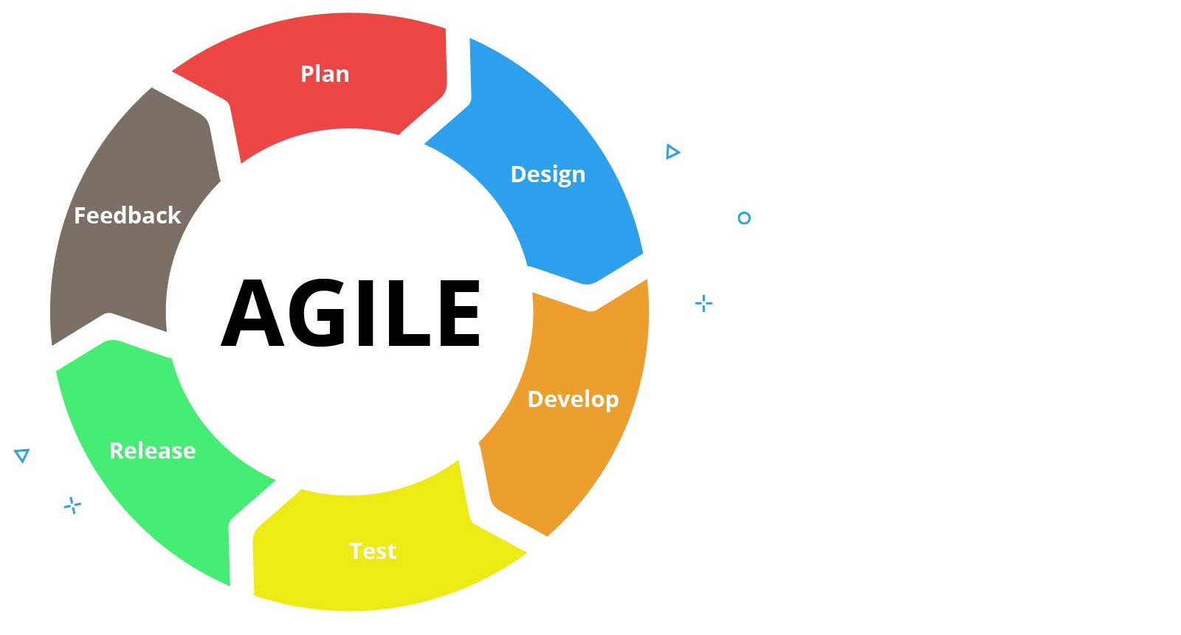

There are many different ways that software or other products can be developed, and Agile methodology is one of them. Agile isn't a program or application; it's a process that has proven effective for many development teams. It consists of tight-knit teams that work together between the business side and the development side of a project. Agile development promotes constant inspection, reflection, and adaptation. This mindset uses several specialized terms that refer to different roles that people on the team take on.

Agile Terminology

**Scrum Diagram**

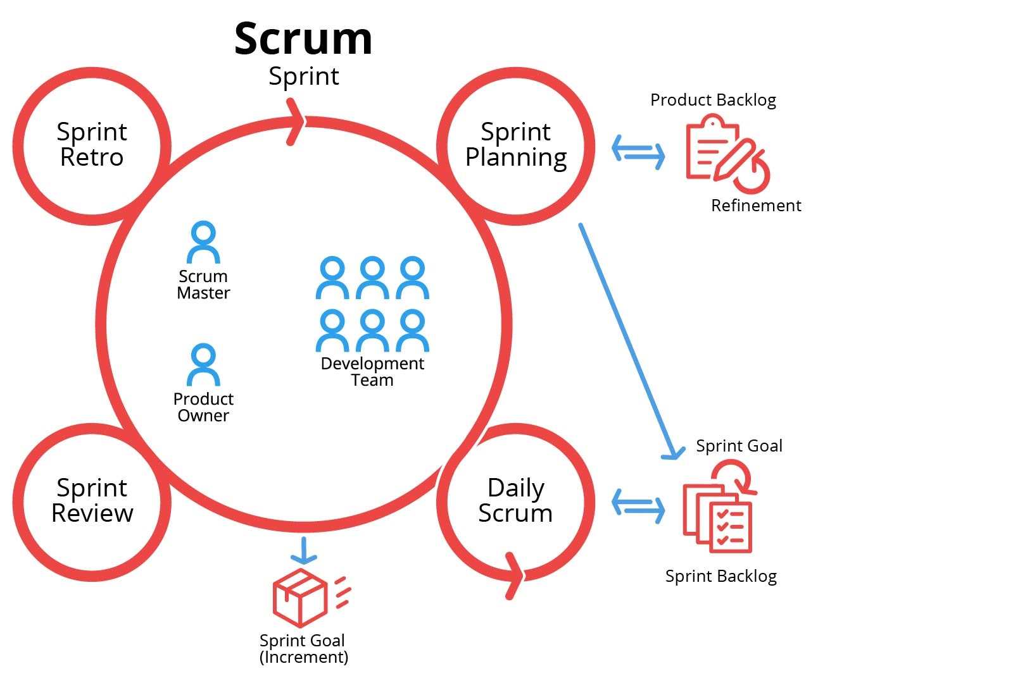

**Iterative Development**

One of the first terms that's good to know is iterative development. An iteration is a cycle that's repeated over and over. When developing a product, the hope is that each iteration will make the product better through team collaboration.

**Scrum**

Another term that's often used with the Agile development process is Scrum. Scrum is an Agile framework, which in this context is just a certain collection of practices that must be consistently followed. The goal of using Scrum is to keep the overhead for the process as low as possible in order to maximize development time.

**Scrum Master**

During the Scrum process, each day starts with a meeting that's led by the project manager, who's known as the Scrum Master. It's the Scrum Master's job to schedule meetings, run them, and make sure that everyone is being as productive as possible. During a Scrum meeting, people usually report on what they've already accomplished and what they plan on doing that day.

**Sprints**

The Scrum process is built around Sprints. A Sprint is a time period where the Scrum team works together on a specific goal. These can as short (a week) or long (up to several weeks) depending on the nature of the goal. A general rule is that the more complex the task, the shorter the sprint should be so that the team can collaborate more often. That way they can keep errors from getting out of control

In a Scrum process there are three artifacts, or things that are created. These are the Product Backlog, the Sprint Backlog, and the Increment.

**Product Backlog**

The Product Backlog is a central list of work that needs to be done. It's a dynamic list that constantly changes to include new features, enhancements, and bug fixes that need to take priority.

**Sprint Backlog**

The Sprint Backlog is a list of things from the Product Backlog that have been prioritized to be worked on in the next **Sprint Cycle**. The team meets together before a Sprint starts and decides what belongs on the list.

**Increment**

The Increment is also known as the **Sprint Goal**. This is the finalized end product that should be completed by the end of the Sprint.

**Product Owner**

The Product Owner is the person on an Agile team who gets to decide what goes on the Sprint Backlog and when a task is sufficiently complete. He or she facilitates the quality control of the product to make sure the team is meeting the goals they set out to accomplish.

Agile Development Benefits

This development process has become popular because it provides many benefits to both developers and customers. Customers enjoy a developer who can respond easily to their requests, and developers enjoy the lower overhead. Teams like the fact of having less busywork to do, and workers often feel more valued because they're working on things that they're most effective at doing.

In this activity, you will compare and contrast media files with different settings. Write a short paragraph on each of the following topics.

1. Explain the concepts of sampling and sampling rate. Then, listen to this 2 kHz file, this 8kHz file, and this 44.1 kHz file and compare their sound. *Depending on your speakers, you may not notice any difference.*
2. Explain the concept of compression and the difference between lossy and lossless compression. Then, compare this 601 kB file and this 33.7 kB file. Was lossy or lossless compression used? How did compression affect the image?
3. Explain the concept of bit depth in audio recordings. Then, listen to this 8-bit recording and this 32-bit recording and compare their quality.
4. Describe the difference between raster and vector images. Then, compare this raster image and this vector image. *In both images, the bottom TestOut logo is an enlarged version of the top logo.*
5. Describe the concept of image resolution. Then, compare this 94 x 140 image and this 604 x 900 image.

[Legal](https://www.comptia.org/legal)Copyright © The Computing Technology Industry Association, Inc. All rights reserved.

Image files have become commonplace in all kinds of computers and devices. That said, not all image files are the same. Generally, image files take up much more space than things like document and spreadsheets files, and different image file formats take up different amounts of storage space as well, depending on the quality. Some formats are better for sharing on social media, while others are better for websites or print. Knowing about image file formats will help you decide which one is best for your needs.

Image File Formats

**.jpg**

JPEG stands for Joint Photographic Experts Group and is one of the most common image file extensions. You may see it written .jpg or .jpeg. The reason for this goes back to earlier days when there was a discrepancy between Mac and Windows file extension naming conventions. Windows only allowed for three-letter extension names, while Apple computers weren't restricted in this way. Though this limit was eventually lifted on Windows, JPG is still how most users refer to the format.

**JPG Format Example**



JPG is a compressed file type that drastically reduces the file's size by a ratio of 20:1 without sacrificing too much image quality (though it is still a lossy format). It supports 24-bit color which can create a wide variety of shades. This balance makes it a popular format to use on the internet for things like posting to social media and displaying pictures on mobile devices. These types of files are easy to share and can be opened by a wide variety of software both on PCs and Macs.

**.png**

Portable Network Graphics, or PNG, is a raster file format that supports lossless compression of image files. PNG (.png) was released in 1994 to be an improvement on the GIF file format, and it combined many features of both GIF and JPG formats (like JPG, it can support 24-bit color). PNG was meant to create files that could be shared on the internet or used in applications - it was not intended for use in print media.

**PNG Format Example**



One feature that PNG files have that JPG files don't is something called an alpha channel, which facilitates different levels of transparency within an image. This allows PNG files to have transparent backgrounds, making them preferable for web design. PNG files, however, cannot be animated like GIF files.

**.gif**

GIF, or Graphics Interchange Format, was originally released in 1987 by CompuServ. Pronounced either with a hard G ("gif") or a soft G ("jif"), GIF is a lossless format that's often used for web images. Because it stores image data using indexed color, the range is limited to 256 colors. This is in contrast to other file formats that have millions of colors to draw from, meaning that images won't have as much nuance as other file formats. This also means that it's not the ideal format to store and share digital photos because the limited color palette will cause the photos to look grainy and unclear. The limited palette is instead ideal for icons and buttons on the web because they don't require thousands of colors to look good.

Today, the GIF format is most widely used to show animations. GIFs can store multiple images in a single file, then display them one after another like a video on an endless loop.

**Animated GIF Example**



**.tiff**

TIFF stands for Tagged Image File Format. TIFF is a format for storing raster graphics that was created in 1986 to be a standard image format that could be shared across a variety of computer programs. Several corporations worked on its development, including the Aldus Corporation (which became part of Adobe) as well as Microsoft and Hewlett-Packard.

Unlike many other image formats, TIFF is not compressed at all. This makes it an ideal format for high-quality printing. However, modern web browsers don't support the format without special plugins, which is why we haven't included an example here.

The United States Constitution gives Congress the power "to promote the Progress of Science and useful Arts, by securing for limited Times to Authors and Inventors the exclusive Right to their respective Writings and Discoveries" (Article 1 Section 8).

The idea of protecting rights to ideas and discoveries is called copyright. Two other ways that intellectual property can be legally protected are through patents and trademarks. While intellectual property laws vary widely from country to country, this lesson focuses on these rights in the United States.

The table below discusses ideas related to copyright and intellectual property.

**Table 1: Copyright and Intellectual Property**

|  |  |
| --- | --- |
| **TERM** | **DESCRIPTION** |
| Copyright | Protections granted by the federal government to creators, writers, and inventors. Copyright includes the rights to reproduce, display, make derivatives, sell, rent, or lend a work.  Copyright is automatically given to creators of works; no application is necessary. Copyrights usually have a time limitation that they are enforceable. For example, in the United States 14 years was the default, but could sometimes be extended. Other countries have varying lengths. |
| Intellectual property | Anything that is owned by a copyright holder is called intellectual property. Some common examples of intellectual property are books, paintings, songs, poems, movies, and inventions. |
| Piracy | Piracy is the crime of using somebody else's intellectual property in a way that should be reserved for the copyright holder. This can include downloading a movie without paying, making photocopies of a book, or selling a copy of a CD. Piracy is punishable by jail time and fines. |
| Fair use | Fair use is an exception to copyright law that allows short excerpts of a copyrighted work to be used for purposes that benefit the public. Such uses include criticism, teaching, research, and news reporting. However, it should be noted that fair use is not a right; it's a legally defensible position. |
| Public domain | Works whose copyrights have expired enter the public domain. Public domain works are free for anyone to reproduce, display, and make derivatives. |
| Proprietary software | Any software the publisher retains intellectual property rights to the source code. Most software you buy is proprietary. Generally, the end user has the right to use the software but does not have the right to make and distribute unauthorized copies. |
| Open-source software | Software anyone can inspect, enhance, and modify the source code. Open-source software is often free and often has several optional third-party add-ons to enhance the product. Common open-source software examples are GIMP and the Linux operating system. |
| Patent | A license given by a government that provides inventors a temporary monopoly or protection on an invention. For example, patent holders can prevent other people from making, selling, or using their patented invention for a certain amount of time. In exchange, the patent holder must provide the public with clear and detailed disclosure of how the invention works.  The patent system encourages innovation by guaranteeing the rights of inventors to make money from their inventions for a few years. At the same time, making the details of an invention public can inspire further innovation.  To get a patent, an inventor must submit (or register) an application to the federal patent office. The application is reviewed by a panel of relevant experts and judges. An inventor should also register a patent with other countries for further protection. |
| Trademark | A trademark is any word, picture, or symbol that's used to distinguish a good from other similar goods. An example is the name of a company or the logo used by a company. Unlike copyright and patents, which are intended to protect creators, trademarks exist to protect consumers. Trademarks make it easy for people to know who makes a product. Trademarks can also help each brand establish a standard of quality that consumers can expect.  There are a wide variety of symbols that can serve as trademarks. These include words, phrases, logos, illustrations, colors, and even sounds. Anything that distinguishes one brand from another can be used as a trademark.  There are two symbols used to designate a trademark. The TM simply means the company is asserting that it has a trademark. The R in a circle means the trademark has been formally registered with the US Patent and Trademark office.  *Trademark infringement* is the act of trying to mislead customers by pretending to be another brand. Take Dr. Pepper for example. When you get to the soda aisle, you'll likely encounter a few off-brand sodas, like Dr. Lightning, Dr. J, or Dr. Salt. These are all fine because it's easy to distinguish them from the original. However, if a soda company used a similar name like Dr. Popper, the company could be sued for trademark infringement. |
| Digital goods | Digital goods, also known as digital products, are intangible products that exist only in a digital form. This means the product is available to customers only as binary computer data, such as e-books in PDF format, Wikipedia articles, music, and Netflix videos.  Since the content is in a digital form, it is easier to steal and copy. To help protect your company against illegal use of digital products, you can use access control technologies to restrict the use of your digital data.  These types of controls are known as digital rights management (DRM) or technological protection measures (TPM). DRM and TPM help you control the use, modification, and distribution of your copyrighted digital data.  As part of these features, companies often try to force users to pay for the use of their digital products. Technologies used to help protect digital data include such things as, using product keys, limited installation activation, encryption, anti-tampering, etc. |

In this age of digital media, copyright laws are more important than ever. It's easier than ever to share media over the internet, and artists must be sure to secure intellectual protection for their works or face losing income to digital piracy.

In order to address some of the issues raised by antiquated copyrights laws in modern times, Congress passed the Digital Millennium Copyright Act (DMCA) in 1998. The law didn't go into effect until the year 2000, however, and has been a source of controversy ever since.

**DMCA Logo**



What Is the DMCA?

The purpose of this law was to protect artists of all types (musical, visual, literary, etc.) from having their work pirated through technology. It sought to balance the rights of content creators and content consumers in the new digital era. It spells out how to enforce copyright issues that arise from technology use, and it also sets forth penalties for those who use technology to abuse copyright laws. Content creators don't have to officially register their work in order to enjoy protection. As soon as something is published, it automatically becomes protected by the DMCA.

It's important to note that this law is only valid in the United States; it's not an international treaty. This means that even if the copyright owner lives outside the US, they can still use the DMCA to make a claim if the offending website is hosted there. Even so, many businesses in other countries still respect the provisions of the DMCA because they're similar to copyright laws in their own countries.

The DMCA is meant to be flexible by not mentioning specific kinds of technology and social media. The law doesn't need to be updated every time a new kind of technology comes out.

The DMCA protects the following kinds of media:

* Written texts such as blog posts, books, and articles
* Digital images and artwork
* Digital music and other audio files
* Digital videos
* Digital software

Under the DMCA, companies and sites can be served with a DMCA takedown notice, which is an official notice that they're violating copyright law. They're told to immediately take down the offending material. If the party does not comply, the ISP can forcibly take down the content themselves. Any content creator can file a DMCA takedown notice, and the receiving party can file a counterclaim. If this happens, the content creator has 14 days to present a lawsuit.

What Is a Safe Harbor?

One provision of the DMCA is that certain places (generally websites) are designated as "safe harbors," giving these websites a safe haven from prosecution. This helps those who are acting as go-betweens from being held liable for any copyright infringement happening on their platforms. So even if an ISP technically allows you to use their service to transmit copyrighted information, the law cannot hold them accountable.

There are four safe harbors under the DMCA:

* System caching
* Information location tools
* Temporary digital network communication
* Storing information at the user's request on a system or network
* Careers in information systems typically require the ability to see the big picture as it relates to large and complex computer systems. They also need to understand the details involved in integrating various systems with each other. This lesson overviews a few common careers in information systems.
* **Table 1: Information Systems Careers**

| **JOB TITLE** | **DESCRIPTION** |
| --- | --- |
| Information Systems Manager | An information systems manager is in charge of integrating different technologies and systems within an organization, including data security, company policies and procedures such as disaster recovery and backup, and quality control when implementing new systems. IS managers are responsible for installing and maintaining current hardware and software as well as planning for future technology needs. They recruit, hire, and supervise a team of IT professionals, coordinating and monitoring daily projects and enforcing company standards. Candidates for these positions usually hold a bachelor's degree in computer or information science and often graduate degrees in business management or information systems. Although a career in IS management requires a high level of education and experience, six figure median salaries provide a strong incentive to get into the field. |
| Project Manager | Project managers are responsible, detail-oriented professionals who know how to manage a team to get things done on time and under budget. A project manager can have a wide range of duties, including monitoring project deadlines, adjusting plans and schedules when problems arise, assigning tasks to team members, and overseeing budgets and timelines. Project managers can work in any IT field, in addition to other fields such as construction management and manufacturing engineering. Since project managers deal with many people on different teams, they need great communication skills, which allow them to coordinate with customers, their own team members, and any other stakeholders involved in a project. To get a job as a project manager in the IT world, you typically need at least a bachelor's degree in business or computer science. Many companies also prefer that candidates have the PMP or Project Management Professional certification, along with certifications specifically designed for IT Service Management. |
| Systems Analyst | Systems analysts are trusted professionals who consult with organizations to help them improve the effectiveness of their information systems. They analyze and assess the performance of existing systems to suggest how a business can operate more efficiently. By understanding the business needs of their clients, talking to users, and consulting with management teams, systems analysts are in a good position to persuade business leaders to implement changes. They also produce specifications and provide user training for new or modified systems. These responsibilities require strong analytical, interpersonal, and presentation skills. In addition to a degree in computer science, information systems, or a related field, systems analysts need several years of experience working with business information systems and collaborating with engineering and development teams. |